**Lab 5**

01)

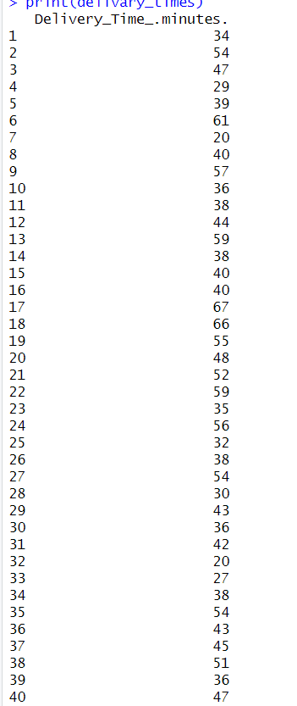

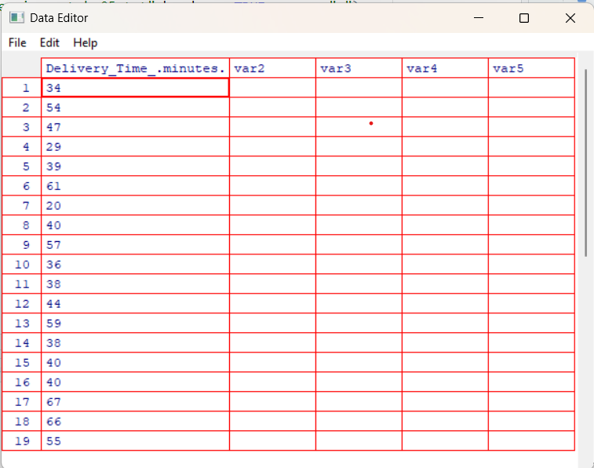

02)

 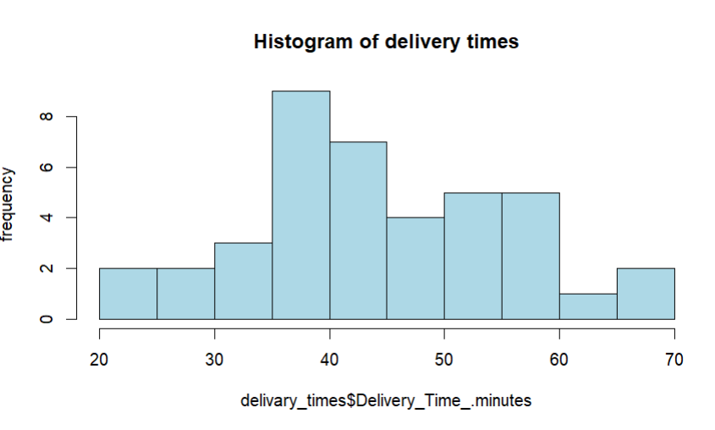

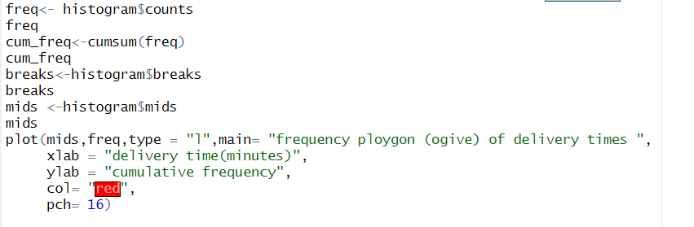

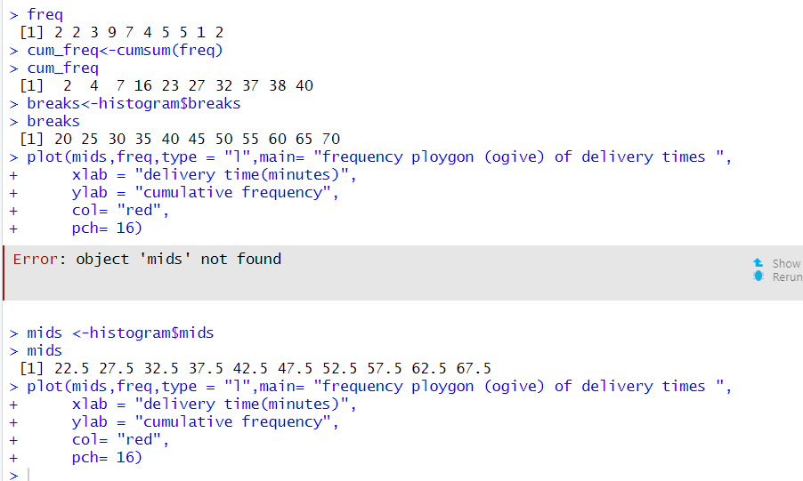

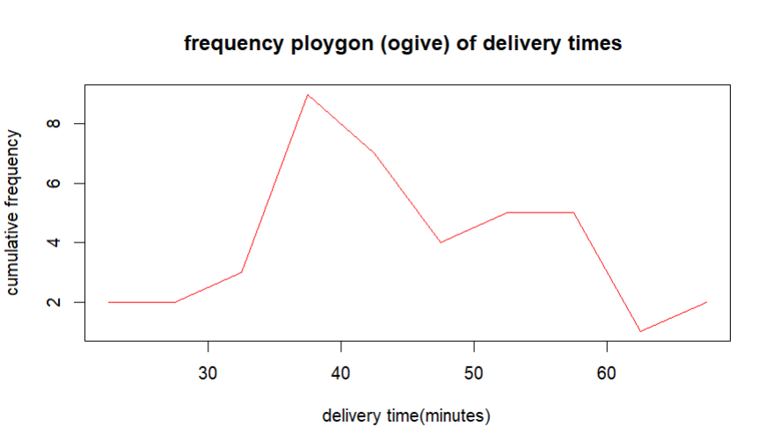

03)

The shape of the histogram is approximately symmetric and bell-shaped, with most delivery times clustering around the middle (35 – 45 minutes) and fewer at the lower and higher ends.

04)

